**ASSIGNMENT 3**

**Q1. Create and compress a file with bzip2.**

**Solution:** Created a file named myfile.txt with the **yes** command to create a large file in less time i.e. of size 188M. Then, compressed with bzip2 using command **bzip2 myfile.txt.** After compression a tar file is created by the name **myfile.txt.bz2** with size **9.9K**

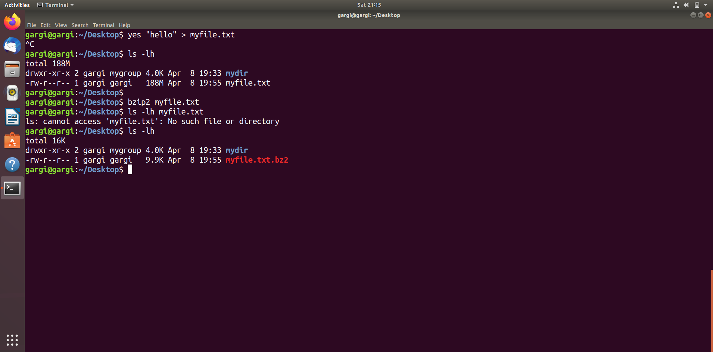

**Q2. What should be the argument to be given to unzip that file.**

**Solution:** To unzip the compressed file named **myfile.txt.bz2** the **–d option** is used with the bzip2 command. You can also use bunzip2 command to unzip bz2 file. Refer the command **$ bunzip2 try.txt.bz2**

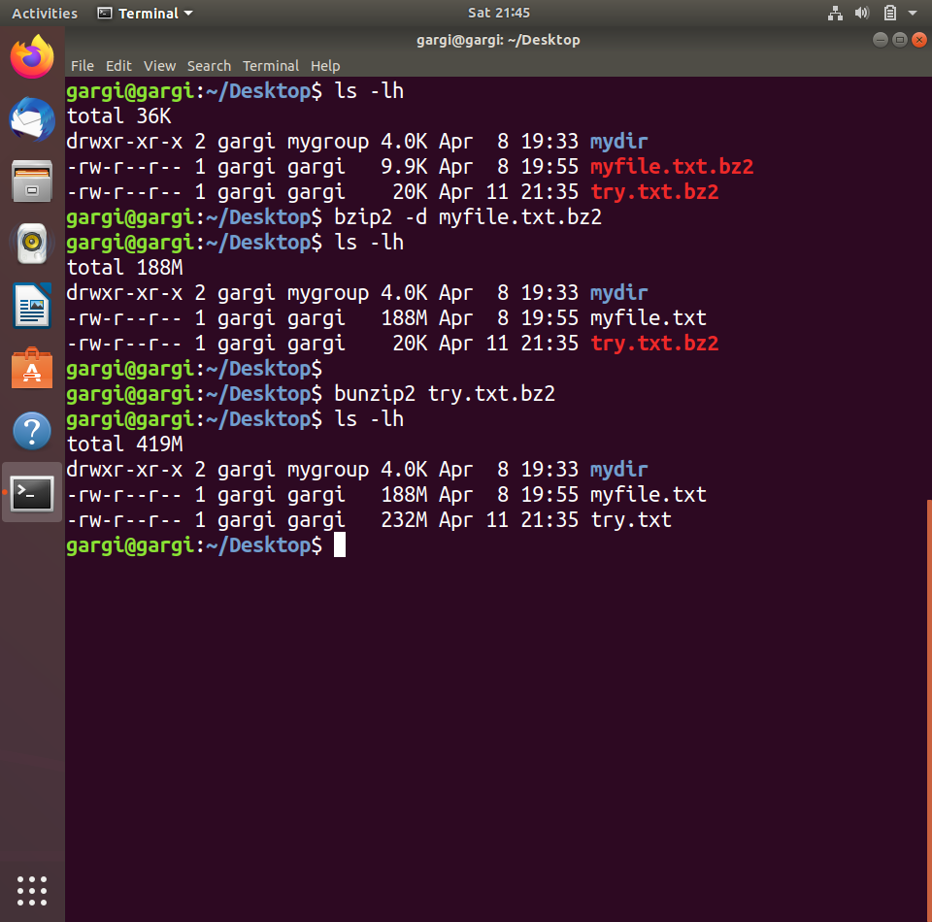

**Q3. Read a file & show the data on terminal using file input & output redirection**

**Solution:** The following command will be used to read/view a file using input/ output redirection

$ cat > docfile.txt

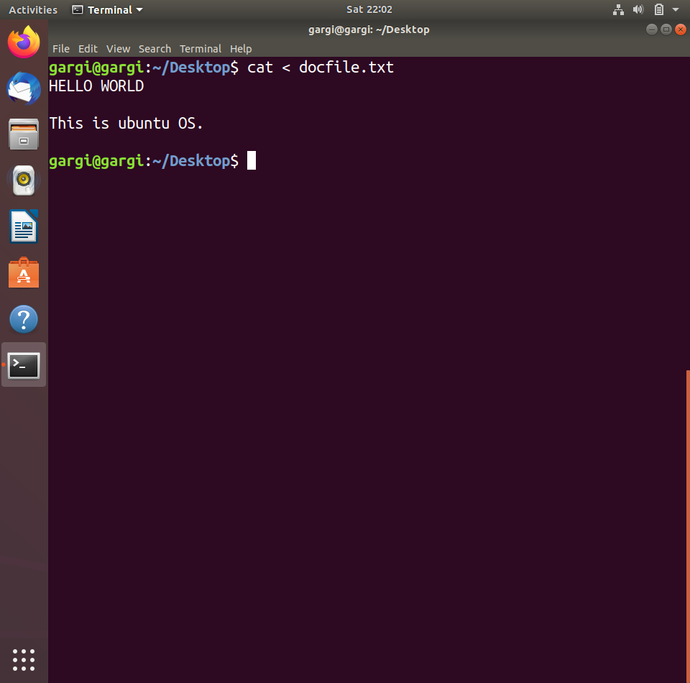

**Q4. How to change the shell of user to “/bin/sh” at the time of adding the user?**

**Solution:** Changing shell of user **g** from **/bin/bash** to **/bin/sh** using the command usermod command to modify the user details and along with it using the **--shell** option to change the login shell of user.

Command is: $ sudo usermod --shell /bin/sh g

